Assignment 1 report
edinterested in so that I can analyze them later. I started by adding some indie folk songs to my playlist, such as pirate's gospel. Since I wanted to achieve the goal of finding songs similar to this one, I then added ”Happy Indie Folk” playlist by Jennywren and “Indie folk mix” created by Spotify. The former is a playlist of indie folk I found online, while the latter is a playlist recommended to me by the spotify algorithm. I combined the two to form a new playlist at https://open.spotify.com/playlist/2lGgVTsqaU0muyyT3zbU4G.

Task 1 Sort by Audio Features
According to the teacher's guidance, each feature represents a feeling of music. I researched the Spotify audio features and discovered that it refers to the various meanings used to describe music. Spotify calculates these features by using audio analysis algorithms and machine learning techniques. These algorithms are based on a large amount of training data and music analysis models, which can automatically extract and calculate various features of music. The features such as danceability', 'energy', 'key', 'loudness', 'mode', 'speechiness', are used in Spotify's recommendation system to understand the similarities between a user's preferences. Some of the features are their basic features, such as keys, modes, speed, and time characteristics. Some are more related to the signal of the audio file itself (loudness, duration). Some are more descriptive feature like danceability. However, I'm not sure how the machine calculate the descriptive features. So, I sorted the features by “energy” from high to low energy. (Figure 1)
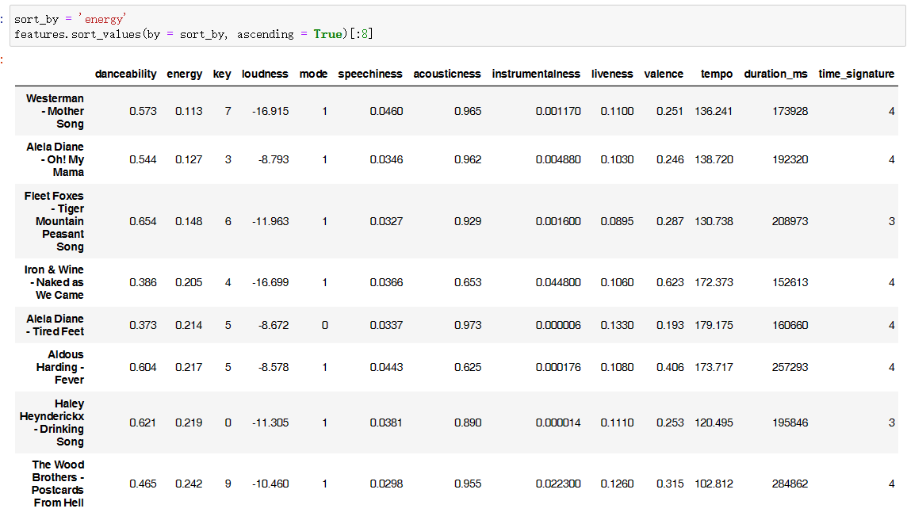
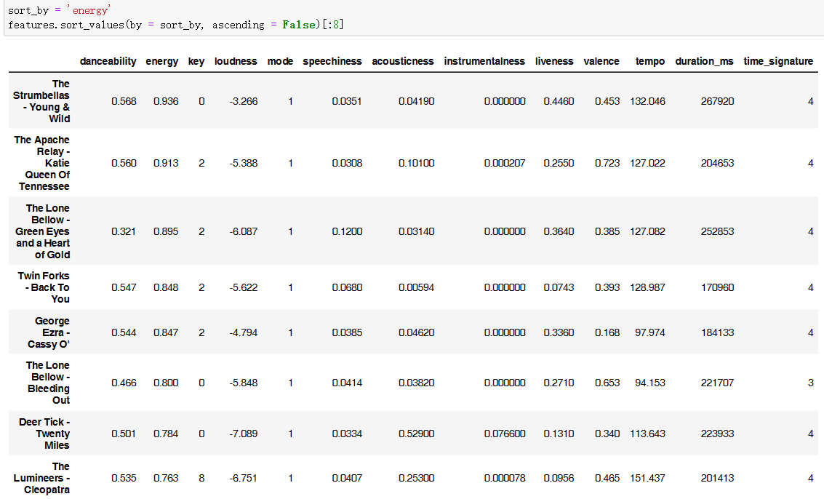
Figure 1 sorted the features by “energy” (high to low) Figure 2 sorted the features by “energy” (low to high)

I found that songs with high energy had higher loudness, higher liveness, and lower acousticsness. According to my research, The energy characteristics can be calculated by analyzing volume, frequency, and timbre variations in music. (Pastukhov,D., 2022) A low value may indicate a low intensity of the music, giving a relaxed feeling, while a high value may indicate a high intensity of the music, giving a feeling of passion. I analyzed the songs in the playlist and generated a chart from the songs in the playlist from high energy to low energy. (Figure 2) To some extent, it is correct. The energy is also related to volume, when the volume is low, the energy is relatively low, but it needs to combine the music style, emotion, lyrics, etc., and the low value and high value of each characteristic may be different for the perception of individuals, because the feeling of music is subjective. Different people may have different preferences for the same musical characteristics. Below shows the features of all songs in the playlist. (Figure 3)
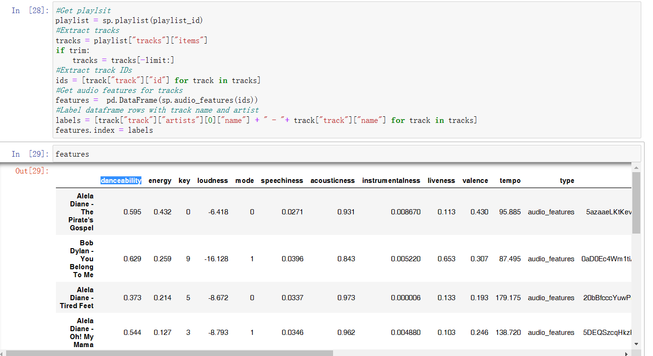
Figure 3 all songs features

Task 2 Song similarity
Danceability, mode, 'duration_ms', 'time_signature' were dropped because they were not main factor to compare 2 similar Indie folk. I used heat map (Figure 4) to find the relative and I found two songs made by the same author in the same album will have a high similarity, and then two songs with similar rhythms and similar styles will also have a high similarity.
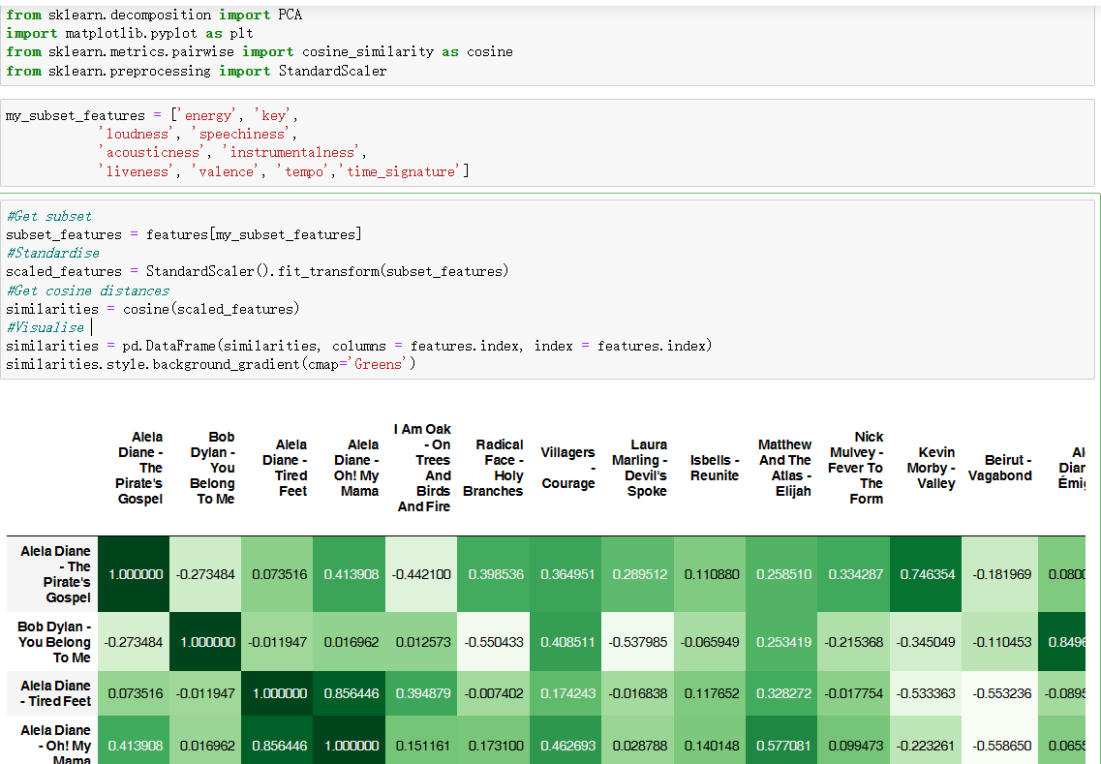
Figure 4 Heat map
I listened several similar songs and found the rhythm and melody are similar, but the emotions expressed are different. Although I think another similar song is good, I don't really appreciate as the former song. The creation of the song has the emotion conveyed by the author. In order to improve this similarity, I think there is still a long way to go, because people's senses are different. Maybe two songs are very similar, but subtle lyrics or just a small difference will become a great difference.

Task 3 Top N Recommendations
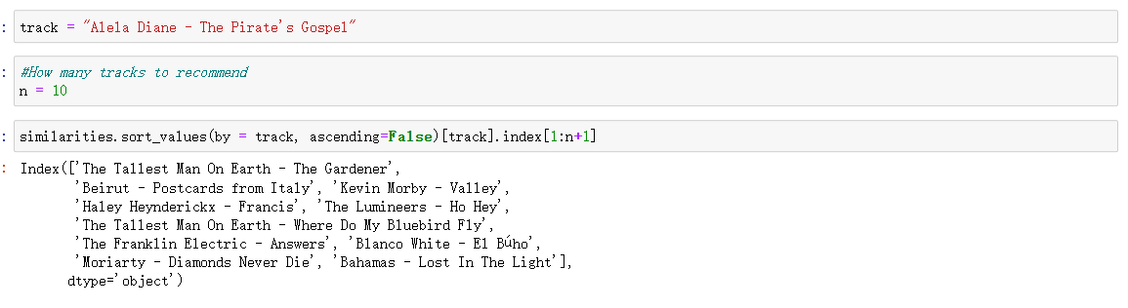
Figure 5 Top 10 similar song
I chose Alela Diane's the pirate's gospel as a track to check out the top ten songs that are similar to it. The result is shown in figure 5.

Task 4 PCA Visualisation

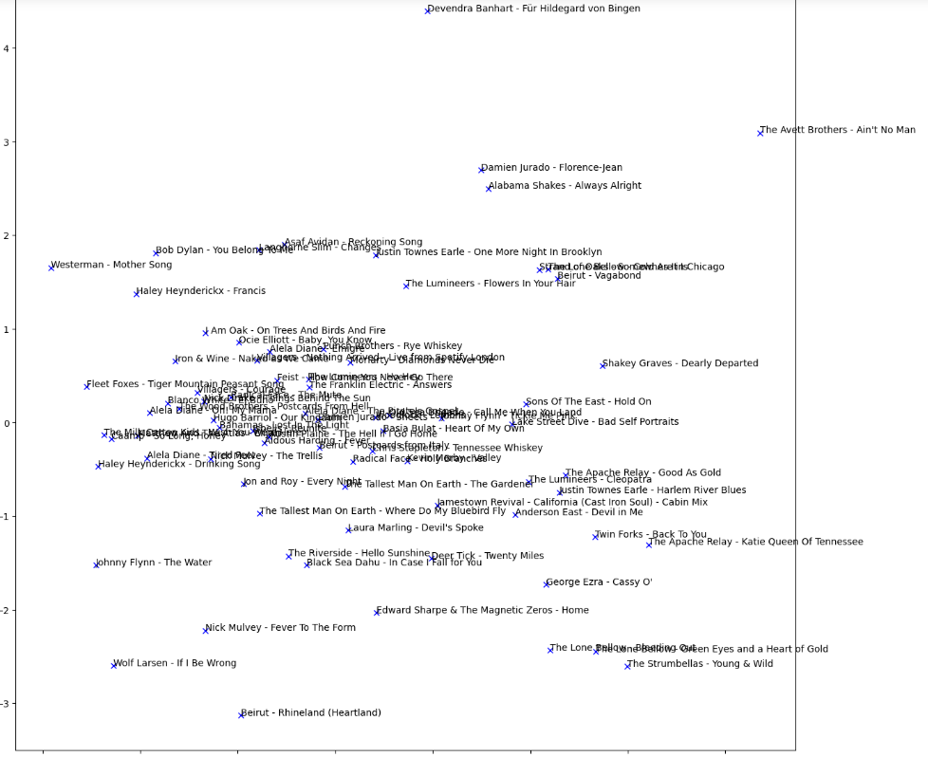

Figure 6 PCA Visualisation

Reference:

Jennywren (n.d.). "Happy Indie Folk" [Location on Spotify]. Spotify. Retrieved June 12, 2023.
Available at: https://open.spotify.com/playlist/15gDsBGwq1bPllgI0cFSsc

"Indie folk mix" [Location on Spotify]. Spotify. Retrieved June 12, 2023.
Available at: https://open.spotify.com/playlist/37i9dQZF1EIfjV34mXjFem

Pastukhov, D. (2022, February 9). Inside Spotify’s Recommender System: A Complete Guide to Spotify Recommendation Algorithms. Music Tomorrow. Retrieved from https://www.music-tomorrow.com/blog/how-spotify-recommendation-system-works-a-complete-guide-2022

